***Types of recursion***

There are 4 types of recursion:

* Linear Recursion
* Tail Recursion
* Binary Recursion
* Mutual Recursion

1/ Linear Recursion:

Linear Recursion is a function when no pending operation involves another recursive to call the function.

Example: Factorial function.

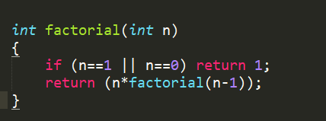

2/ Tail Recursion:

Tail Recursion is another form of linear recursion, where the function makes a recursive call as its very last operation.

Example: Compute the GCD of two numbers.

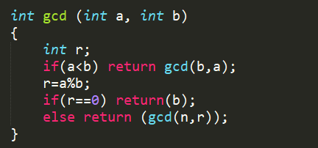

3/ Binary Recursion:

Functions with two recursive calls are reffered to as binary recursive functions.

Example: Fibonacci number.

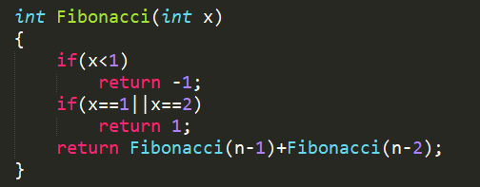

4/ Mutual Recursion:

When functions calling each other, this is mutual recursion. It’s not actually recursive but doing the same as recursive, it can be applied to any into one or all functions.

Example: Find odd and even number.

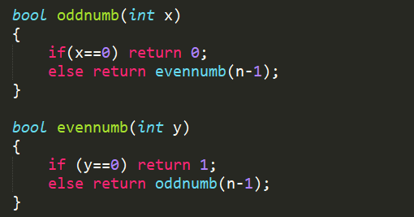

References:

<http://www.tutorial4beginners.com/ds-types-recursion>

<http://cs-fundamentals.com/c-programming/recursion-in-c.php>

<http://www.dreamincode.net/forums/topic/51296-types-of-recursion/>

<http://www.sparknotes.com/cs/recursion/whatisrecursion/section2/>